Individual Weekly Report for Sam Baranov

Gym App

July 14, 2025

# Accomplishments

* Had instructor meeting to finalize the project direction
* Presented Showcase 1
* Scheduled first stakeholder meeting
* Made a low fidelity Figma prototype to model possible UI flows
* Started high fidelity Figma prototype utilizing actual Material 3
* Created a visual database schema representation

# Weekly Activities

| Activity / Task / Work | Hours | Status |
| --- | --- | --- |
| Instructor Meet | 0.5 | Complete |
| Showcase 1 Presentation | 0.5 | Complete |
| Class Time | 2.5 | Complete |
| Figma Low Fidelity Prototype work | 7 | Complete |
| Figma Low Fidelity Prototype work | 6.5 | Complete |
| Figma High Fidelity Prototype work | 0.5 | In progress |
| Database Schema Modeling | 3 | In progress |
| Status Report 3 | 0.5 | Complete |
| **Weekly Total** | **21** |  |
| Previous Weekly Cumulative Total (Carry Over) | 34 |
| **Current Cumulative Total** | **55** |

# Plans for Next Week

| Activity / Task / Work | Est Hours |
| --- | --- |
| Finalize Design Spec | 4-6 |
| Draft Contract | 2 |
| Finish High Fidelity Prototype | 10-15 |
| Finish schema and begin data layer implementation | 3 |

# Response to Feedback

Biggest piece of feedback has been in regards to how I should approach the prototype design. While I initially planned to immediately into high fidelity, during the meeting, a suggestion from two people was to focus on the overall flow, so I have instead opted to design flows in a low fidelity prototype, and compress the actual high-effort screens so that they can be more closely modeled and copied for actual implementation.

# Other Reflections

Majority of the time this week has been spent trying to figure out the actual UX of the app. I anticipated that this will be the most difficult part of actual design planning, and I was correct. Based on feedback as previously mentioned, I ended up working on a very rough, low fidelity prototype to actually figure out overall flows for myself, and then compressing it into a high-fidelity prototype with few, but polished screens in actual Material 3 design.

This was clearly the correct idea, as even on low fidelity prototype, I ended up doing and redoing it multiple times, just to try to figure out a possible flow. I do think, however, that time spent on this right now will greatly streamline actual development, as ideally I would like to avoid working on design problems during the programming stage.

I have decided to also do the same for the database schema, as it should streamline that process going forward.

# Comments, Issues, Notes, Anything Else?

Biggest issue has been that I have left laptop and graded initial draft of design specifications in Bremerton (along with my whole bag, I was visiting a friend), and only got it back on Sunday, so I haven’t had a chance to actually work on finalizing the spec. I have salvaged it by focusing on prototype and database modeling instead.

# Evidence of Work

## Figma Prototype Work

Low fidelity prototype used for ideation. I realized I have some of these components from another project, so I ended up using them to quickly go through whole bunch of screens. Next up is transforming it into a high fidelity Material 3 based prototype that I shall use during stakeholder meeting.

## Database Schema Design

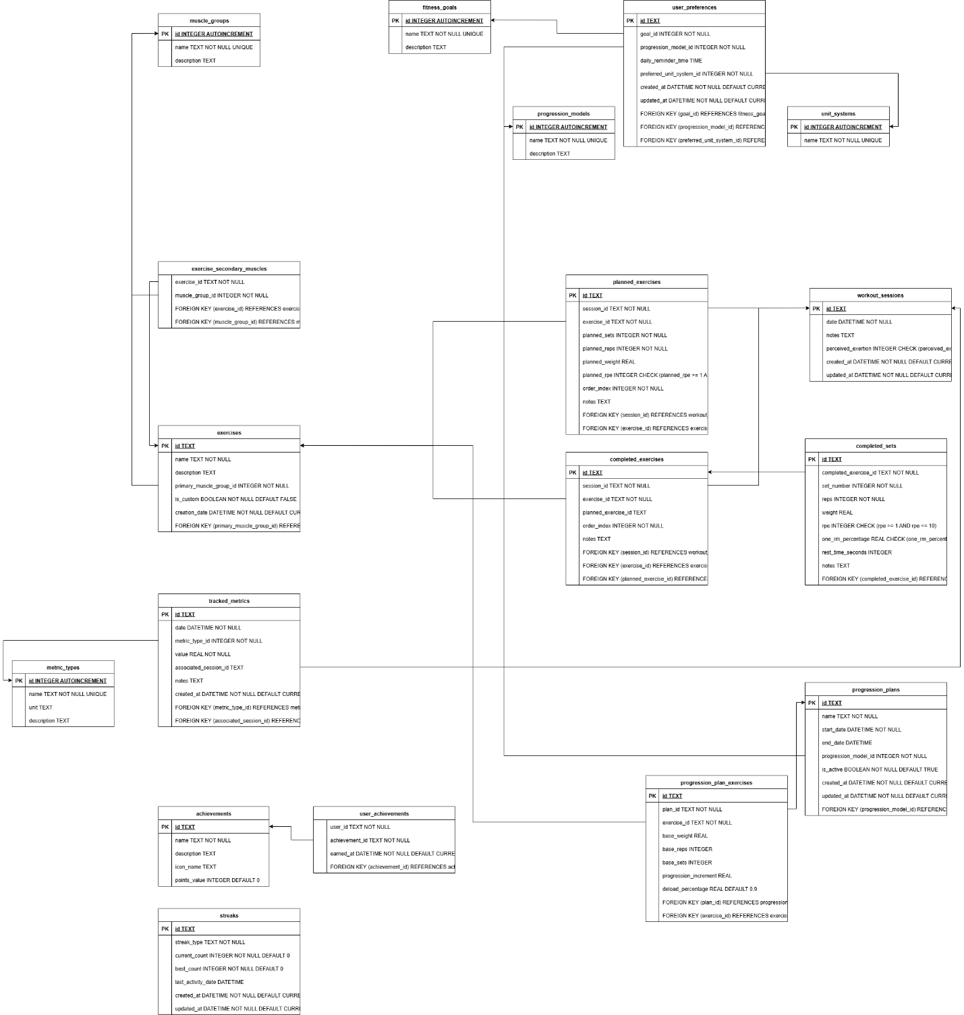

Database schema based on design doc.

Informational interview (I have no idea how to remove this, it doesn’t have “Remove Content Protection”)